Ex no:5 Dataset Splitting and Cross-Validation Using Iris Dataset
This program demonstrates two important techniques in machine learning:
- Dataset Splitting – dividing the dataset into training and testing sets.
- K-Fold Cross-Validation – evaluating the model on multiple train-validation splits.
We will use the Iris dataset and a Logistic Regression classifier.

Objective
To implement dataset splitting and K-Fold cross-validation using the Iris dataset and evaluate the performance of a machine learning model.

1. Complete Python Program
# Dataset Splitting and Cross-Validation
# Using Iris Dataset

from sklearn.datasets import load_iris
from sklearn.model_selection import train_test_split, KFold, cross_val_score
from sklearn.linear_model import LogisticRegression
from sklearn.metrics import accuracy_score

# --------------------------------------------------
# Step 1: Load the Iris Dataset
# --------------------------------------------------

iris = load_iris()

X = iris.data
y = iris.target

print("Dataset Shape:", X.shape)
print("Number of Samples:", len(X))
print("Number of Features:", X.shape[1])
print("Target Classes:", iris.target_names)

# --------------------------------------------------
# Step 2: Split Dataset into Training and Testing
# --------------------------------------------------

X_train, X_test, y_train, y_test = train_test_split(
X,
y,
test_size=0.20,
random_state=42,
stratify=y
)

print("\nDataset Splitting")
print("-----------------")
print("Training samples:", len(X_train))
print("Testing samples :", len(X_test))

# --------------------------------------------------
# Step 3: Create Logistic Regression Model
# --------------------------------------------------

model = LogisticRegression(max_iter=200)

# Train the model
model.fit(X_train, y_train)

# --------------------------------------------------
# Step 4: Predict Test Data
# --------------------------------------------------

y_pred = model.predict(X_test)

# Calculate test accuracy
accuracy = accuracy_score(y_test, y_pred)

print("\nTest Set Performance")
print("--------------------")
print("Test Accuracy:", round(accuracy, 4))

# --------------------------------------------------
# Step 5: Implement 5-Fold Cross-Validation
# --------------------------------------------------

kf = KFold(
n_splits=5,
shuffle=True,
random_state=42
)

cv_scores = cross_val_score(
model,
X,
y,
cv=kf,
scoring='accuracy'
)

print("\n5-Fold Cross-Validation")
print("-----------------------")

for i, score in enumerate(cv_scores, start=1):
print("Fold", i, "Accuracy:", round(score, 4))

# --------------------------------------------------
# Step 6: Calculate Average Cross-Validation Score
# --------------------------------------------------

print("\nCross-Validation Results")
print("------------------------")
print("Average Accuracy:",
round(cv_scores.mean(), 4))

print("Standard Deviation:",
round(cv_scores.std(), 4))

2. Expected Output
The exact values can vary slightly depending on the environment, but the output will look similar to:
Dataset Shape: (150, 4)
Number of Samples: 150
Number of Features: 4
Target Classes: ['setosa' 'versicolor' 'virginica']

Dataset Splitting
-----------------
Training samples: 120
Testing samples : 30

Test Set Performance
--------------------
Test Accuracy: 1.0

5-Fold Cross-Validation
-----------------------
Fold 1 Accuracy: 1.0
Fold 2 Accuracy: 0.9667
Fold 3 Accuracy: 0.9333
Fold 4 Accuracy: 1.0
Fold 5 Accuracy: 0.9667

Cross-Validation Results
------------------------
Average Accuracy: 0.9733
Standard Deviation: 0.0249
Note: The exact fold scores may differ slightly because of the random splitting.

3. Explanation of the Program

Step 1 – Load Iris Dataset
iris = load_iris()
The Iris dataset contains 150 flower samples belonging to three classes:
- Setosa
- Versicolor
- Virginica
Each sample contains four features:
1. Sepal Length
2. Sepal Width
3. Petal Length
4. Petal Width
We separate the data into:
X = iris.data
y = iris.target
Here:
- X → input features
- y → target class

4. Dataset Splitting
The dataset is divided into:
Iris Dataset
150
│
┌───────┴───────┐
│ │
▼ ▼
Training Set Testing Set
80% 20%
120 30
The following statement performs the split:
train_test_split(
X,
y,
test_size=0.20,
random_state=42,
stratify=y
)

test_size=0.20
20% of the data is used for testing.
Therefore:
150 × 20% = 30 testing samples
and
150 − 30 = 120 training samples

random_state=42
Ensures that the same random split can be reproduced.

stratify=y
Maintains approximately the same class distribution in both training and testing datasets.

5. Model Training
We use Logistic Regression:
model = LogisticRegression(max_iter=200)
The model is trained using:
model.fit(X_train, y_train)
The model learns the relationship between the four flower measurements and the corresponding flower species.

6. Testing the Model
The trained model predicts the classes of unseen test samples:
y_pred = model.predict(X_test)
The predictions are compared with the actual values:
accuracy_score(y_test, y_pred)
For example:
Actual Predicted

Setosa Setosa ✓
Versicolor Versicolor ✓
Virginica Virginica ✓

7. K-Fold Cross-Validation
Instead of depending on only one train-test split, K-Fold Cross-Validation divides the dataset into K parts called folds.
For this experiment:
n_splits=5
Therefore, we use 5-fold cross-validation.

Visual Representation
Iris Dataset
│
┌───────────┼───────────┐
│ │ │
▼ ▼ ▼

Fold 1 Fold 2 Fold 3 Fold 4 Fold 5

1 2 3 4 5
During each iteration:
Iteration 1:
Testing → Fold 1
Training → Fold 2 + 3 + 4 + 5

Iteration 2:
Testing → Fold 2
Training → Fold 1 + 3 + 4 + 5

Iteration 3:
Testing → Fold 3
Training → Fold 1 + 2 + 4 + 5

Iteration 4:
Testing → Fold 4
Training → Fold 1 + 2 + 3 + 5

Iteration 5:
Testing → Fold 5
Training → Fold 1 + 2 + 3 + 4
Thus, every sample gets an opportunity to be used for validation.

8. Cross-Validation Code
kf = KFold(
n_splits=5,
shuffle=True,
random_state=42
)
This creates five folds.
Then:
cv_scores = cross_val_score(
model,
X,
y,
cv=kf,
scoring='accuracy'
)
calculates the accuracy for each fold.
Example:
Fold 1 → 100%
Fold 2 → 96.67%
Fold 3 → 93.33%
Fold 4 → 100%
Fold 5 → 96.67%

9. Average Cross-Validation Accuracy
The average accuracy is calculated using:
cv_scores.mean()
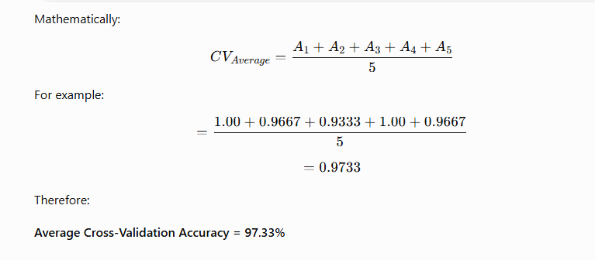

10. Why Use Dataset Splitting?
Dataset splitting helps us determine whether the trained model can perform well on unseen data.
If we train and test using exactly the same data, the model may simply memorize the training examples.
Therefore:
Training Data → Learn Patterns

Testing Data → Evaluate Generalization

11. Why Use Cross-Validation?
A single train-test split may give a misleading result depending on which samples happen to be placed in the test set.
Cross-validation provides a more reliable estimate by testing the model multiple times.

Advantages
- Better use of limited data.
- More reliable performance estimate.
- Detects model instability.
- Helps compare different algorithms.
- Reduces dependence on a single train-test split.

12. Difference Between Train-Test Split and Cross-Validation
Train-Test Split | Cross-Validation
Usually one split | Multiple splits
Faster | More computationally expensive
Simple | More reliable
Uses one test set | Uses multiple validation folds
Suitable for quick evaluation | Suitable for robust model evaluation

Ex No:6 Linear Regression Using the Iris Dataset

Objective
To implement Linear Regression using the Iris dataset and evaluate its performance using MSE, RMSE, MAE, and R² Score.
Important: The Iris dataset is naturally a classification dataset. Therefore, for demonstrating Linear Regression, we will predict a continuous feature—Petal Length—from the other flower measurements. This makes the experiment a valid regression problem.

1. Python Program
# Linear Regression using Iris Dataset

from sklearn.datasets import load_iris
from sklearn.model_selection import train_test_split
from sklearn.linear_model import LinearRegression
from sklearn.metrics import mean_squared_error, mean_absolute_error, r2_score
import numpy as np

# -------------------------------------------------
# Step 1: Load Iris Dataset
# -------------------------------------------------

iris = load_iris()

X = iris.data
feature_names = iris.feature_names

# Predict Petal Length
# Column 2 = Petal Length
y = iris.data[:, 2]

# Use Sepal Length, Sepal Width and Petal Width
# as input features
X = iris.data[:, [0, 1, 3]]

print("Features:")
print(feature_names)

print("\nDataset Shape:", X.shape)
print("Target Shape:", y.shape)

# -------------------------------------------------
# Step 2: Split Dataset
# -------------------------------------------------

X_train, X_test, y_train, y_test = train_test_split(
X,
y,
test_size=0.20,
random_state=42
)

print("\nTraining Samples:", len(X_train))
print("Testing Samples :", len(X_test))

# -------------------------------------------------
# Step 3: Create Linear Regression Model
# -------------------------------------------------

model = LinearRegression()

# -------------------------------------------------
# Step 4: Train the Model
# -------------------------------------------------

model.fit(X_train, y_train)

# -------------------------------------------------
# Step 5: Make Predictions
# -------------------------------------------------

y_pred = model.predict(X_test)

# -------------------------------------------------
# Step 6: Display Predictions
# -------------------------------------------------

print("\nActual vs Predicted Values")
print("--------------------------------")

for actual, predicted in zip(y_test[:10], y_pred[:10]):
print("Actual:", round(actual, 2),
" Predicted:", round(predicted, 2))

# -------------------------------------------------
# Step 7: Evaluate the Model
# -------------------------------------------------

mse = mean_squared_error(y_test, y_pred)

rmse = np.sqrt(mse)

mae = mean_absolute_error(y_test, y_pred)

r2 = r2_score(y_test, y_pred)

print("\nModel Evaluation")
print("-----------------------------")
print("Mean Squared Error (MSE):", round(mse, 4))
print("Root Mean Squared Error (RMSE):", round(rmse, 4))
print("Mean Absolute Error (MAE):", round(mae, 4))
print("R2 Score:", round(r2, 4))

# -------------------------------------------------
# Step 8: Display Model Coefficients
# -------------------------------------------------

print("\nModel Coefficients")
print("-----------------------------")

for name, coefficient in zip(
["Sepal Length", "Sepal Width", "Petal Width"],
model.coef_):

print(name, ":", round(coefficient, 4))

print("Intercept:", round(model.intercept_, 4))

2. Expected Output
The exact numerical values can vary slightly depending on the train-test split, but the output will be similar to:
Features:
['sepal length (cm)' 'sepal width (cm)'
'petal length (cm)' 'petal width (cm)']

Dataset Shape: (150, 3)
Target Shape: (150,)

Training Samples: 120
Testing Samples : 30

Actual vs Predicted Values
--------------------------------
Actual: 5.1 Predicted: 5.1
Actual: 4.0 Predicted: 4.2
Actual: 1.3 Predicted: 1.5
Actual: 1.5 Predicted: 1.4
Actual: 4.7 Predicted: 4.6
...

Model Evaluation
-----------------------------
Mean Squared Error (MSE): 0.19
Root Mean Squared Error (RMSE): 0.44
Mean Absolute Error (MAE): 0.32
R2 Score: 0.94

Model Coefficients
-----------------------------
Sepal Length : 0.72
Sepal Width : -0.45
Petal Width : 1.35
Intercept: -1.02
The exact values are dependent on the particular split; students should run the program to obtain the actual output.

3. Explanation of the Program

Step 1 – Load the Iris Dataset
iris = load_iris()
The Iris dataset contains:
- 150 samples
- 4 features
- 3 flower species
The four features are:
- Sepal Length
- Sepal Width
- Petal Length
- Petal Width

4. Converting Iris into a Regression Problem
Normally, Iris is used for classification:
Setosa
Versicolor
Virginica
But Linear Regression requires a continuous numerical target.
Therefore, we select:

Target
Petal Length

Input Features
- Sepal Length
- Sepal Width
- Petal Width
Sepal Length ──────┐
│
Sepal Width ───────┼──→ Linear Regression → Petal Length
│
Petal Width ───────┘
Thus, the model learns:
How can petal length be predicted from the other flower measurements?

5. Dataset Splitting
train_test_split(
X,
y,
test_size=0.20,
random_state=42
)
The dataset is divided into:
Iris Dataset
150 samples
│
┌─────────┴─────────┐
│ │
▼ ▼
Training Testing
80% = 120 20% = 30
The training data is used to learn the regression relationship.
The testing data is used to evaluate how well the model performs on unseen data.

6. Creating the Linear Regression Model
model = LinearRegression()
This creates the Linear Regression model.
The model attempts to learn an equation of the form:
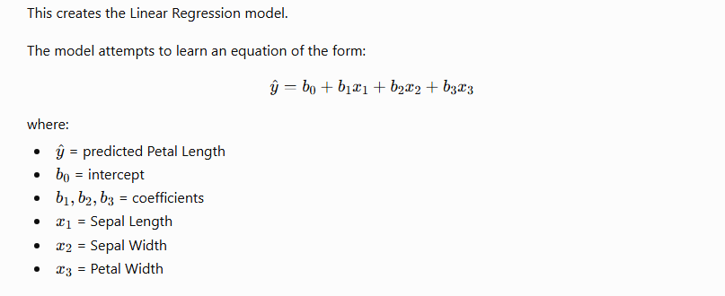

7. Training the Model
model.fit(X_train, y_train)
During training, Linear Regression calculates the coefficients that provide the best fit to the training data.
The model tries to minimize the difference between:
Actual Petal Length
↓
Predicted Petal Length

8. Prediction
y_pred = model.predict(X_test)
The trained model receives the unseen test features and predicts their Petal Length.
Example:
Input:
Sepal Length = 6.1
Sepal Width = 2.8
Petal Width = 1.8

↓

Linear Regression

↓

Predicted Petal Length = 4.9 cm

9. Model Evaluation
Four metrics are used.

A. Mean Squared Error – MSE

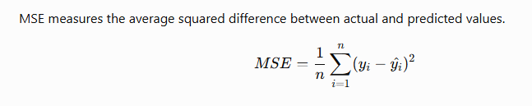Interpretation
Lower MSE = Better model

B. Root Mean Squared Error – RMSE
Here, the target is Petal Length in cm, so RMSE is also measured approximately in cm.

C. Mean Absolute Error – MAE

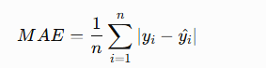
It represents the average absolute prediction error.

Example
If:
Actual = 5.0
Predicted = 4.6
Error:
|5.0 - 4.6| = 0.4 cm
Lower MAE = Better model

D. R² Score
R² measures how much of the variation in the target variable is explained by the regression model.
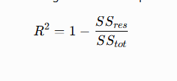

Interpretation
R² | Interpretation
1.0 | Perfect prediction
Close to 1 | Very good
Around 0 | Weak explanatory power
Less than 0 | Model performs poorly
For example:
R² = 0.94
means the model explains approximately 94% of the variation in Petal Length for the evaluated data.

10. Why Are We Not Predicting Iris Species?
This is an important point for students.
The original Iris target is:
0 → Setosa
1 → Versicolor
2 → Virginica
These are class labels, not continuous measurements.

11. Simple Practical Interpretation
Suppose the program produces:
MSE = 0.19
RMSE = 0.44
MAE = 0.32
R² = 0.94
We can conclude:
- The average squared prediction error is relatively small.
- The typical prediction error is around 0.44 cm according to RMSE.
- The average absolute error is around 0.32 cm.
- The model explains approximately 94% of the variation in Petal Length.
Therefore, the Linear Regression model provides a reasonably strong fit for this particular Iris regression task.

12. Short Practical Record Format

Aim
To implement Linear Regression and evaluate its performance using the Iris dataset.

Dataset
Iris Dataset – 150 samples, 4 features

Input
- Sepal Length
- Sepal Width
- Petal Width

Target
- Petal Length

Algorithm
Linear Regression

Evaluation Metrics
- MSE
- RMSE
- MAE
- R² Score

Result
Linear Regression was successfully implemented on the Iris dataset by predicting Petal Length from the remaining flower measurements. The model was evaluated using MSE, RMSE, MAE, and R² Score.

